DSA Youth Basketball League Team Information Form Feb 25th – Mar 26 th, 2023
(Please sign one form for each division)

Team Name: __________________________
Coach: _____________________ Contact No.:___________________
Assistant Coach: ______________________________
Email: ______________________________________________________
Division (delete the divisions not appropriate to you) | U8 | U10 | U12 | U14 | U16 | U18 | U16 Girls | (*Max. 12 Players)

 | Name  (Alphabetic order, last name first) | Age | Jersey Top Size | Jersey Bottom Size | Date of Birth  (DD/MM/YY) | Completed vaccination (Y/N)
1
2
3
4
5
6
7
8
9
10
11
12

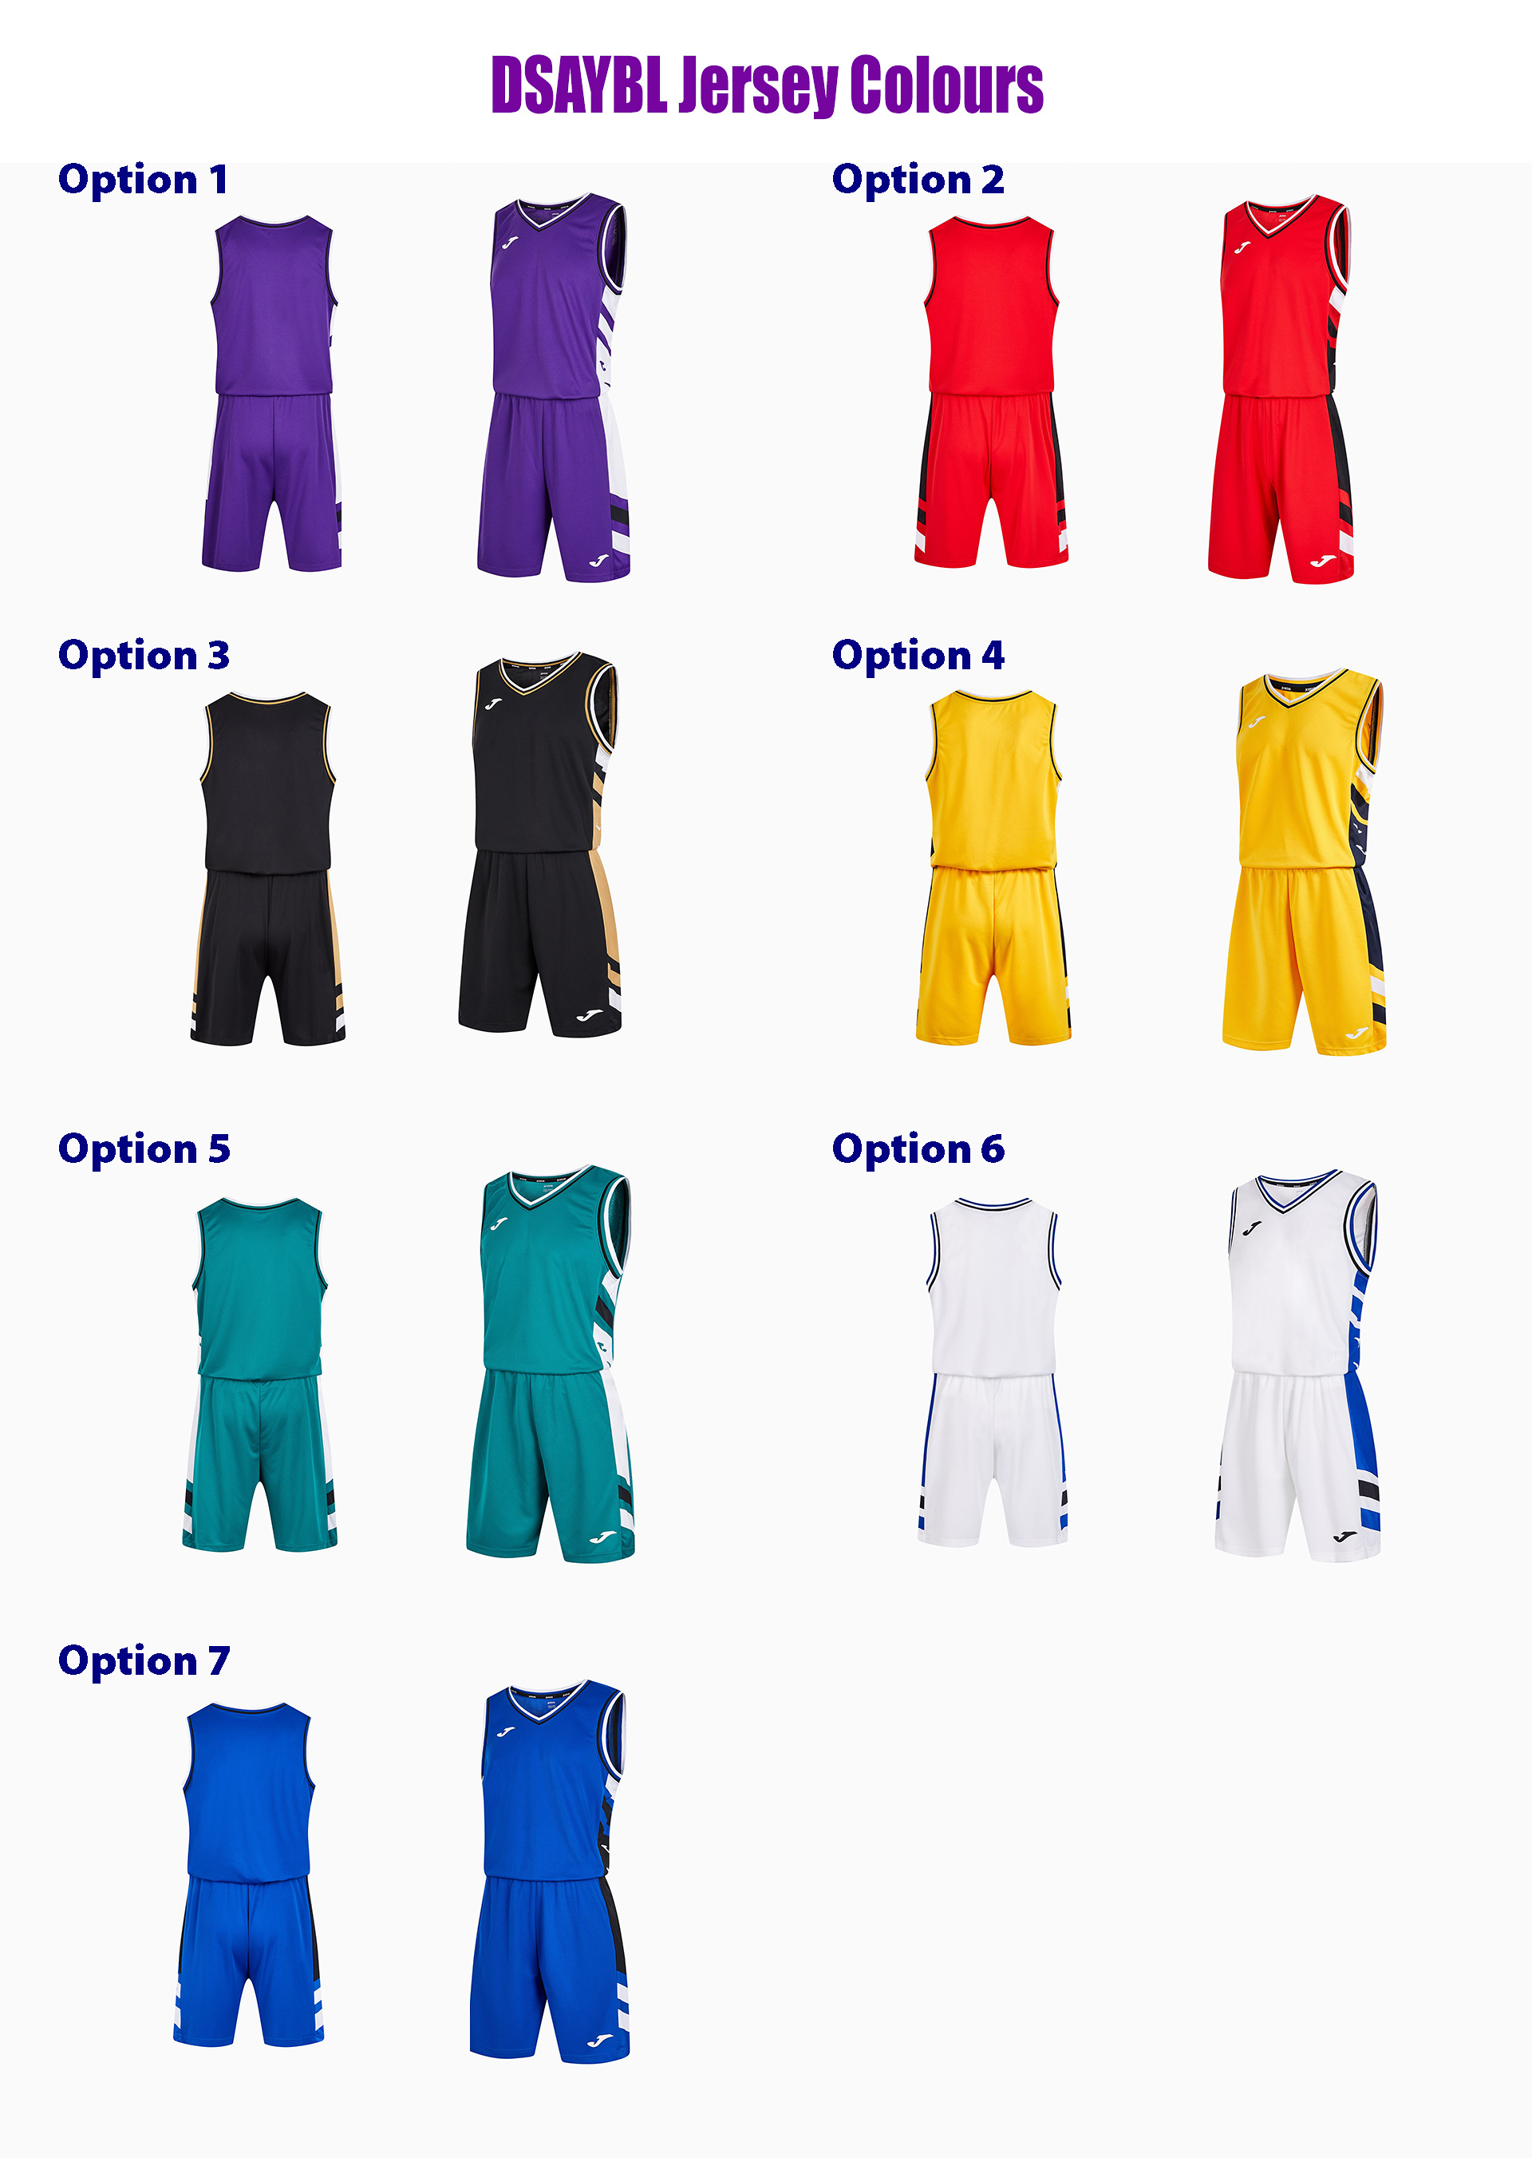
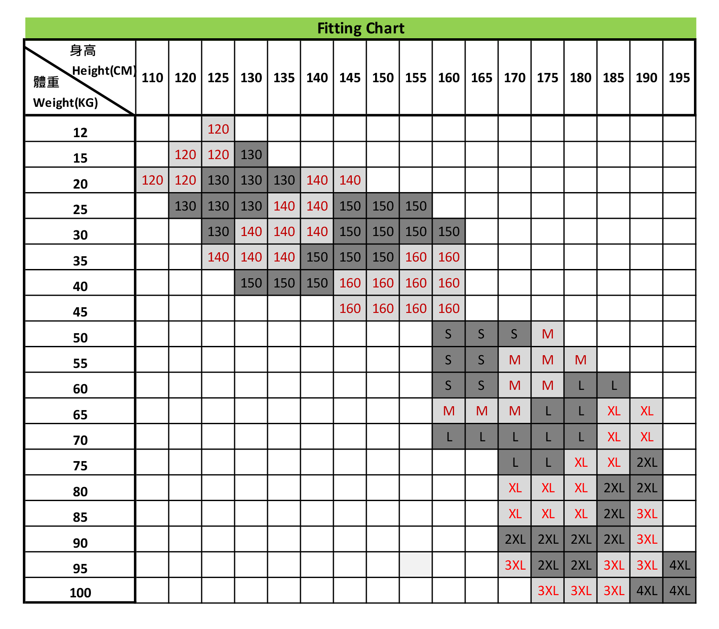
Choose your team’s Jersey colour option (If a Jersey is chosen, the option will be taken off the online form list)

Option: _______

Special Requests: _____________________________________________________________________________
_____________________________________________________________________________
____________________________________________________________________________

Division Age Requirements:
U8: Born in or after Sep 1st 2014
U10: Born in or after Sep 1st 2012
U12: Born in or after Sep 1st 2010
U14: Born in or after Sep 1st 2008
U16: Born in or after Sep 1st 2006
U18: Born in or after Sep 1st 2004
U16 Girls: Born in or after Sep 1st 2006

*NOTE: All teams will be provided Jerseys designed by DSA and sponsored by Interglobo.

Entry Procedure

- Please respond via email with your intent/confirmation of joining on or before Feb 8th, 2023.

*NOTE: All team rosters must be sent by deadline for pre-approval. Players who have not been previously approved will not be allowed to participate.
*Please send your team logo “ai file” to the following email upon sign up.
Email to: dsaybl@dreamsports.com.hk OR fax to: 852-3462 2625

DSAYBL 2023 Tournaments Rules:

1. All players have to wear a facemask during the games.
2. Coaches, staff and parents will be required to wear a facemask at the venue.
3. All rules will follow official FIBA rules as stated at www.fiba.com/basketball-rules except the following:
4. Games will be 8 minutes running clock except during time outs.
5. Only one (1) minute break will be allowed in between quarters; only two (2) minute break will be allowed in between halves.
6. Only two (2) timeouts of 20 seconds each will be allowed each half in order to move the games along (the schedule, as you can see is very tight).
7. Each Overtime period will be 5 minutes running clock and commence with a jump ball
8. U8/U10/U12/U14/U16/U18 - Running clock except last 2 minutes of 4th quarter. The duration of each timeout is 20 second
9. No family members, non-coaching staff members or non-players will be allowed to sit on or around the bench area
10. After the submission of the rosters, teams cannot add any players to their roster during the league
11. Players ID will be checked before every game
12. After receiving the DSAYBL uniforms, players must wear it in every game of the league
13. No screens will be permitted for both U8 & U10 divisions.

Regarding the full court press rules

For U8, U10 & U12:
1. No full court press will be allowed all time, last two minutes of 4 quarter stop clock
2. No zone defense will be allowed during the tournament.

*Teams must play man-to-man defense for the duration of games and the tournament.
A zone defense is defined as a player clearly marking an area and not an opposing player.
It is the judgment of the match official as to whether a team (or any player on a team) is playing a zone defense.
The opposing coach may raise a complaint to this effect with the match official, but it is the official’s decision as to whether they support that complaint. If a zone is deemed to be played, a violation should be called (similar to a non-shooting defensive foul), and a warning issued to both players and coaches. If a team repeatedly violates this rule, this will be reported to the convener for further action.

For U14, U16 & U18:
1. No full court press will be allowed if the winning team is up by 20 points or more
2. A 24 second shot clock. FIBA rules regarding shot clock re-sets (14 seconds in the appropriate circumstance) will be followed.
3. Four 8 minute running clock quarters with stop clock in the last 2 minutes of the 4th quarter and stop clock during time-outs

Basketball sizes will be as follows: U10 size 5; U12 size 6; U14, U16 and U18 size 7.

Each team will receive two (2) points on the leaderboard for a win, and one (1) point on the leaderboard for a loss

In case of a tie in the leaderboard standings, a winner will be determined using the following:
1. Calculation of each team's point differential over the course of the tournament. If no winner is produced
2. Calculation of each team's total points over the course of the tournament. If no winner is produced
3. Calculation of each team's points allowed during the course of the tournament

Important Notes
In order for this schedule to work for the benefit of everyone and the tournament, please adhere to the following:
The schedule is VERY tight for the tournament.
We are hoping that with the cooperation of each organization and team involved, we can get everyone out early enough to enjoy there evenings.

To help
1. All teams ARRIVE TEN MINUTES BEFORE THE START OF EACH GAME. Be on time, and we finish on time.
2. No warm-up time will be allocated during the game.
Each team must look to warm-up while the previous game is going on so that games can be started as soon as possible.
3. Of course, we understand that many unpredictable things happen with the timing of tournaments, so please anticipate the tournament ending at least one hour after the last scheduled games to play safe. This will allow plenty of time for Overtimes, stoppages for injuries and timeouts, etc.

Awards
MVP of the tournament will be voted by the coaches of each opposite team during each game.

